Software Requirement Specification
ClearSAR

Supervised By
Dr Usman Ghous

Arsalan Hassan 22F-3050
Khizra Shehzadi 22F-3592
Muhammad Hashir 22F-3294



Department of Computer Science
FAST – National University of Computer & Emerging Sciences
Chiniot-Faisalabad Campus
2026

Table of Contents
Table of Contents i
1. Introduction 5
2. Vision Document 5
2.1. Problem Statement: 5
2.2. Business Opportunities 5
2.3. Objectives 5
2.4. Scope 6
2.5. Constraints 6
2.6. Stakeholder and User Description 6
2.6.1. Market Demographics 6
2.6.2. User Environment 7
2.6.3. Stakeholder Profiles 7
2.6.4. Stakeholder Summary 9
3. System Requirements Specification 10
3.1. System Features 10
3.2. Functional Requirements 10
3.2.1. Image Upload 10
3.2.2. SAR-to-Optical Translation 10
3.2.3. Scene Description 10
3.2.4. Result Visualization 10
3.2.5. Performance Monitoring 11
3.2.6. Dataset Processing 11
3.2.7. Model Evaluation 11
3.2.8. Authentication 11
3.3. Non-Functional Requirements 11
3.3.1. User-Friendly Interface 11
3.3.2. Data Security 11
3.3.3. Performance 11
3.3.4. Privacy 12
3.3.5. Scalability 12
3.3.6. Reliability 12
3.3.7. Maintainability 12
3.3.8. Usability 12
. Design Artifacts 13
4.1. Use Case Diagram 13
4.2 High Level Use Cases 13
4.3 Expanded Use Cases 16
4.3.1. Use Case 1: Upload SAR Image 16
4.3.2. Use Case 2: Validate File 17
4.3.3. Use Case 3: Translate Image 18
4.3.4. Use Case 4: Generate Description 19
4.3.5. Use Case 5: View Results 19
4.3.6. Use Case 6: View Metrics 20
4.3.7. Use Case 7: Monitor Performance 21
4.3.8. Use Case 8: Evaluate Model 21
4.3.9. Use Case 9: Manage Dataset 22
4.4 Activity Diagram 24
4.5 Package Diagram 25
4.6 Sequence Diagram 26
4.7 System Sequence Diagrams 27
4.7.1 Upload SAR Image 27
4.7.2 Translate Image 28
4.7.3 View Results 29
4.7.4 Monitor Performance 30
4.7.5 Evaluate Model 31
4.7.6 Manage Dataset 32
4.8 Data Flow Diagram 33
4.8.1 Data Flow Diagram: Level 0 33
4.8.2 Data Flow Diagram: Level 1 33
4.8.3 Data Flow Diagram: Level 2: Translation Process 34
4.9 Deployment Diagram 34
4.9 Component Diagram 35
5. References 36

List of Figure
Figure 1: Use Case Diagram for Exoress2Heal 14
Figure 2 Acitivity Diagram for ClearSAR 25
Figure 3 Package Diagram For ClearSAR 26
Figure 4 Sequence Diagram for ClearSAR 27
Figure 5 SSD Upload SAR Image 28
Figure 6 SSD Translate Image 29
Figure 7 SSD View Results 30
Figure 8 SSD Monitor Performance 31
Figure 9 SSD Evaluate Model 32
Figure 10 SSD Manage Dataset 33
Figure 11 DFD Level 0 for ClearSAR 34
Figure 12 DFD Level 1 for ClearSAR 34
Figure 13 DFD Level 2: Translation Process for ClearSAR 35
Figure 14 Deployment Diagram for ClearSAR 35

List of Tables
Table 1:Problem Statement 6
Table 2: Supervisor Team 8
Table 3: Development Team 9
Table 4: End Users 9
Table 5: Admin 10
Table 6: Stakeholder Summary 10
Table 7: Upload SAR Image 14
Table 8: Validate File 15
Table 9: Translate Image 15
Table 10: Generate Description 15
Table 11: View Results 16
Table 12: View Metrics 16
Table 13: Monitor Performance 16
Table 14: Evaluate Model 17
Table 15: Manage Dataset 17
Table 19: Upload SAR Image 17
Table 20: Validate File 18
Table 21: Translate Image 19
Table 22: Generate Description 20
Table 23: View Results 20
Table 24: View Metrics 21
Table 25: Monitor Performance 22
Table 26: Evaluate Model 23
Table 27: Manage Dataset 23

Introduction
This document describes the software requirements for ClearSAR, a web-based AI system that translates Synthetic Aperture Radar (SAR) images into optical-style images and generates automated scene descriptions. It is intended for developers, supervisors, evaluators, and stakeholders.

2. Vision Document

2.1. Problem Statement:
Table 1:Problem Statement
Category | Description
Problem | - SAR imagery is difficult to interpret due to speckle noise, unfamiliar visual patterns, and geometric distortions. Manual analysis requires expertise and is time-consuming.
Affects | - Disaster responders, analysts, environmental researchers, defense organizations, and urban planners who rely on fast image interpretation.
Impact | - Delays in decision-making, limited accessibility to SAR data, reduced operational efficiency in time-critical scenarios.
Solution | A web-based AI platform that automatically translates SAR images into optical-style visuals and generates scene descriptions using deep learning models.

2.2. Business Opportunities
ClearSAR provides significant commercial and research value:
- Can be used by disaster management authorities for rapid analysis
- Supports environmental monitoring agencies
- Useful for defense surveillance applications
- Potential integration with satellite data platforms
- Scalable SaaS solution for remote sensing organizations
.

2.3. Objectives
The objectives of ClearSAR are:
- Develop SAR-to-optical translation using Latent Diffusion Models
- Generate automated scene descriptions using BLIP-2 vision-language model
- Build production-grade web application (React + FastAPI)
- Achieve quality metrics: PSNR > 20dB, SSIM > 0.6
- Ensure processing time < 40 seconds per image
- Provide deployment-ready system and documentation

2.4. Scope
ClearSAR focuses on:
- Uploading SAR imagery
- Converting SAR → optical image
- Generating natural language scene description
- Visualizing results in browser
- Supporting research and operational analysis
Initial version supports:
- 256×256 images
- Web platform access
- Pre-trained + fine-tuned AI models

2.5. Constraints
- Model accuracy depends on dataset quality
- Requires GPU for efficient inference
- Limited performance on unseen SAR distributions
- Internet required for web app access
- Processing speed depends on server resources

2.6. Stakeholder and User Description

2.6.1. Market Demographics
Target users include:
- Remote sensing analysts
- Disaster management teams
- Environmental researchers
- Military intelligence analysts
- Students and researchers

2.6.2. User Environment
Users access system via web browser. System runs on cloud or server infrastructure supporting AI inference.

2.6.3. Stakeholder Profiles
The Following Section Outlines the Stakeholder Profiles.

2.6.3.1. Supervisor Team
Table 2: Supervisor Team
Representatives | Supervisor: Dr Usman Ghous
Description | They are involved in supervising activities for the development process.
Type | They are technical stakeholders. They have expertise in the project domain.
Responsibility | - Gives direction to the development team.  - Ensures that the system will be completed in a given time.  - Ensures that the characteristics of the product will be in demand.  - Keep track of the task's development.  - Highlight the development team's stake.  - Ensure the project follows the documents generated during the design phase.  - Ensure that the working product is delivered correctly.
Success Criteria | The completion of features which are being committed by the development team at the start of the project.
Involvement | - Requirement reviewer  - Senior managers senior managers  - Review project progress
Comments | None

2.6.3.2. Development Team
Table 3: Development Team
Representatives | Arsalan Hassan 22F-3050  Khizra Shehzadi 22F-3592  Muhammad Hashir 22F-3294
Description | They are involved in the development of the project.
Type | Technical stakeholders
Responsibility | Fully involved in the development of the project.  Specify requirements like a requirement engineer.  Conduct research system features to develop the model.  Successful development of proposed model  Market Analysis and corporate current emotional issues in the system.
Success Criteria | Successful completion and development of committed features
Involvement | Research and development of the project.  Documentation and development of the project
Comments/Issues | None

2.6.3.3. End Users
Table 4: End Users
Representatives | End Users
Description | They are the project's end users who will use it for their specific purposes.
Type | External stakeholder
Responsibility | Use the product for good purposes.
Involvement | None
Comments/Issues | None

2.6.3.4. Admin
Table 5: Admin
Representatives | Admin
Description | They maintain the application after deployment.
Type | Internal Stakeholder
Responsibility | Ensuring the ClearSAR Platform is functioning normally after deployment.
Involvement | - Track platform performance and user activity to ensure smooth and stable operations.  - Review, validate, and moderate user-submitted content and group chats to maintain a safe environment.  - Oversee user data, manage authentication, and ensure compliance with privacy and security standards.
Comments/Issues | None

2.6.4. Stakeholder Summary
Table 6: Stakeholder Summary
Name | Description | Responsibility
Development Team | The development team will be involved in developing ClearSAR and work as a requirement engineer, project manager and developer. | Fully involved in the development of the project. Specify requirements like a requirement engineer. Conduct research on system features to develop the model. Successful development of the proposed project.
Supervisor Team | Help the development team in successful completion. | Provide technical help and support to the development team.
End User | They are the project's end users and will use it for their own reasons. | End users will use it for good purposes.
Admins | After reviewing the reports, they can accept or reject them. | After examining the information, take or leave it.

3. System Requirements Specification

3.1. System Features
ClearSAR provides:
- SAR Image Upload
- AI Image Translation
- Scene Description Generation
- Result Visualization
- Performance Evaluation Dashboard
- Secure Processing Environment

3.2. Functional Requirements
The system must fulfil specific functional requirements, including:

3.2.1. Image Upload
- System shall allow user to upload SAR image.
- System shall validate file format
- System shall store uploaded image temporarily

3.2.2. SAR-to-Optical Translation
- System shall process uploaded image using diffusion model
- System shall generate optical-style output
- System shall display generated image

3.2.3. Scene Description
- System shall generate textual description of scene
- System shall analyze generated optical image
- System shall display description to user

3.2.4. Result Visualization
- System shall display original SAR image
- System shall display translated optical image
- System shall display generated caption

3.2.5. Performance Monitoring
- System shall measure processing time
- System shall display quality metrics if available.

3.2.6. Dataset Processing
- System shall support SEN12MS dataset input for training.
- System shall support SEN12MS dataset input for training.

3.2.7. Model Evaluation
- System shall compare output with baseline GAN model.
- System shall compute PSNR and SSIM metrics

3.2.8. Authentication
- System shall allow admin login.
- System shall restrict model management to admins.

3.3. Non-Functional Requirements

3.3.1. User-Friendly Interface
The system must have an intuitive and easy-to-navigate interface to ensure accessibility for users of all technical skill levels.

3.3.2. Data Security
It must implement industry-standard encryption and secure protocols to safeguard sensitive user information.

3.3.3. Performance
The system must respond efficiently, processing user inputs and delivering results within a short time, even under high loads.

3.3.4. Privacy
It must prioritize user privacy, ensuring that personal data is protected and anonymity is maintained, especially in virtual support groups.

3.3.5. Scalability
The system must be capable of scaling to accommodate a growing number of users without affecting performance.

3.3.6. Reliability
The system must operate with minimal downtime and ensure continuous availability to users for consistent support.

3.3.7. Maintainability
The system must be easily maintainable, allowing for quick updates and bug fixes without major disruptions to users.

3.3.8. Usability
The system must ensure a high level of usability, providing smooth user experience with clear guidance, minimal errors, and user satisfaction.

. Design Artifacts

4.1. Use Case Diagram
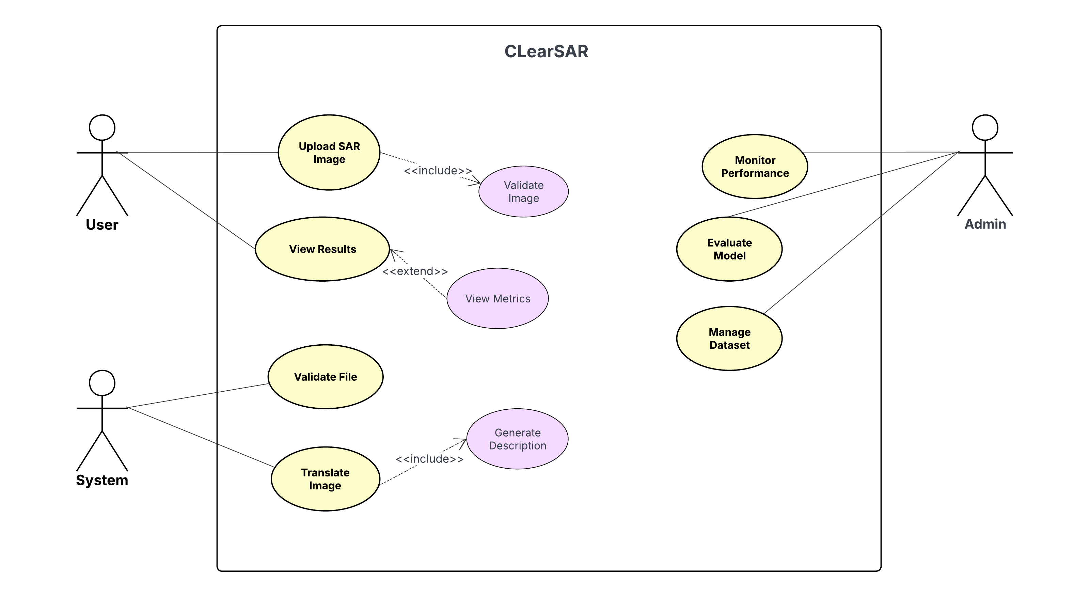

Figure 1: Use Case Diagram for Exoress2Heal

4.2 High Level Use Cases
Use Case 1
Table 7: Upload SAR Image
Use case ID: | UC-01
Use case Name: | Upload SAR Image
Actor | User
Type: | Primary.
Description: | The user uploads a SAR image to the system for processing. The system receives the image and prepares it for validation and translation.

Use Case 2
Table 8: Validate File
Use case ID: | UC-02
Use case Name: | Validate File
Actor | System
Type: | Supporting
Description: | The system verifies the uploaded file format, size, and integrity before allowing further processing.

Use Case 3
Table 9: Translate Image
Use case ID: | UC-03
Use case Name: | Translate Image
Actor | System
Type: | Primary
Description: | The system converts the validated SAR image into an optical-style image using the trained AI model.

Use Case 4
Table 10: Generate Description
Use case ID: | UC-04
Use case Name: | Generate Description
Actor | System
Type: | Supporting
Description: | The system generates a textual scene description based on the translated optical image.

Use Case 5
Table 11: View Results
Use case ID: | UC-5
Use case Name: | View Results
Actor | User
Type: | Primary
Description: | The system displays the original SAR image, translated optical image, and generated description to the user.

Use Case 6
Table 12: View Metrics
Use case ID: | UC-6
Use case Name: | View Metrics
Actor | User
Type: | Secondary
Description: | The system displays evaluation metrics such as PSNR and SSIM if available after processing.

Use Case 7
Table 13: Monitor Performance
Use case ID: | UC-07
Use case Name: | Monitor Performance
Actor | Admin
Type: | Primary
Description: | The admin monitors system performance, processing speed, and operational status through the dashboard.

Use Case 8
Table 14: Evaluate Model
Use case ID: | UC-08
Use case Name: | Evaluate Model
Actor | Admin
Type: | Primary
Description: | The admin evaluates model performance by comparing outputs against baseline models and reviewing metrics.

Use Case 9
Table 15: Manage Dataset
Use case ID: | UC-09
Use case Name: | Manage Dataset
Actor | Admin, External Dataset Source
Type: | Primary
Description: | The admin uploads, updates, or manages training datasets used for system model improvement.

4.3 Expanded Use Cases

4.3.1. Use Case 1: Upload SAR Image
Table 19: Upload SAR Image
Use case ID: | UC-01
Use case Name: | Upload SAR Image
Created by: | ClearSAR Team |  | Last updated by: | ClearSAR Team
Date Created: | 18/02/2026 |  | Revision Date: | 18/02/2026
Actor: |  | User
Description: |  | The system allows the user to upload a SAR image for processing and analysis.
Trigger: |  | User selects an image and clicks upload.
Pre-condition: |  | User has access to system interface and a valid SAR image file.
Post-condition: |  | Image is successfully uploaded and ready for validation.
Normal flow: |  | - User selects SAR image file.  - System receives file.  - System checks file presence.  - System stores file temporarily.  - System forwards file for validation.
Alternative flow: |  | A1: User cancels upload → System returns to dashboard.
Exceptions: |  | Invalid file, upload failure, network interruption.
Includes: |  | Validate File.
Frequency of use: |  | High
Special Requirements: |  | Secure upload handling, file size limit enforcement, supported format validation.

4.3.2. Use Case 2: Validate File
Table 20: Validate File
Use case ID: | UC-02
Use case Name: | Validate File
Created by: | ClearSAR Team |  | Created by: | ClearSAR Team
Date Created: | 18/02/2026 |  | Date Created: | 18/02/2026
Actor: |  | System
Description: |  | The system verifies uploaded image format, size, and integrity before processing.
Trigger: |  | File is uploaded.
Pre-condition: |  | File has been successfully uploaded..
Post-condition: |  | File marked valid or rejected.
Normal flow: |  | - System reads file metadata.  - System checks format compatibility.  - System verifies file size.  - System scans file integrity.  - System approves file for processing
Alternative flow: |  | A1:Format unsupported → Reject file.  A2: File corrupted → Reject file.
Exceptions: |  | File unreadable, validation module error.
Includes: |  | N/A.
Frequency of use: |  | High
Special Requirements: |  | Validation rules database, format whitelist.

4.3.3. Use Case 3: Translate Image
Table 21: Translate Image
Use case ID: | UC-03
Use case Name: | Translate Image
Created by: | ClearSAR Team |  | Created by: | ClearSAR Team
Date Created: | 18/02/2026 |  | Date Created: | 18/02/2026
Actor: |  | System
Description: |  | The system converts a validated SAR image into an optical-style image using AI models.
Trigger: |  | File passes validation.
Pre-condition: |  | Image validated successfully.
Post-condition: |  | Optical image generated.
Normal flow: |  | - System loads AI translation model.  - System preprocesses SAR image.  - System performs translation.  - System generates optical output.  - System stores generated image.
Alternative flow: |  | A1: Processing timeout → Retry processing.
Exceptions: |  | GPU unavailable, model failure, memory error.
Includes: |  | Generate Description.
Frequency of use: |  | Medium to High
Special Requirements: |  | GPU support, trained diffusion model, inference engine.

4.3.4. Use Case 4: Generate Description
Table 22: Generate Description
Use case ID: | UC-04
Use case Name: | Generate Description
Created by: | ClearSAR Team |  | Created by: | ClearSAR Team
Date Created: | 18/02/2026 |  | Date Created: | 18/02/2026
Actor: |  | System
Description: |  | The system generates a natural language description of the translated image scene.
Trigger: |  | Optical image produced.
Pre-condition: |  | Translated image available
Post-condition: |  | Text description generated and stored.
Normal flow: |  | - System loads caption model.  - System analyzes translated image.  - System extracts features.  - System generates description text.  - System saves description.
Alternative flow: |  | N/A.
Exceptions: |  | Model failure, inference error.
Includes: |  | N/A.
Frequency of use: |  | High
Special Requirements: |  | Vision-language model, text generation module.

4.3.5. Use Case 5: View Results
Table 23: View Results
Use case ID: |  | UC-05
Use case Name: |  | View Results
Created by: |  | ClearSAR Team | Created by: | ClearSAR Team
Date Created: |  | 18/02/2026 | Date Created: | 18/02/2026
Actor: | User
Description: | The system displays the SAR image, translated image, and generated description.
Trigger: | Processing completes.
Pre-condition: | Image processing finished successfully.
Post-condition: | Results displayed to user.
Normal flow: | - System retrieves stored outputs.  - System loads original image.  - System loads translated image.  - System loads description.  - System displays results.
Alternative flow: | A1: Metrics available → Show metrics option.
Exceptions: | Display failure, data retrieval error.
Includes: | N/A.
Frequency of use: | High
Special Requirements: | Image viewer, UI rendering module.

4.3.6. Use Case 6: View Metrics
Table 24: View Metrics
Use case ID: | UC-06
Use case Name: | View Metrics
Created by: | ClearSAR Team |  | Created by: | ClearSAR Team
Date Created: | 18/02/2026 |  | Date Created: | 18/02/2026
Actor: |  | User
Description: |  | The system displays evaluation metrics such as PSNR and SSIM for the processed image.
Trigger: |  | User selects metrics option.
Pre-condition: |  | Metrics available.
Post-condition: |  | User's journal entry is saved and analysed by the AI system
Normal flow: |  | - User clicks metrics option.  - System retrieves evaluation metrics.  - System displays values.
Alternative flow: |  | A1: Metrics unavailable → Display message
Exceptions: |  | Metrics data missing.
Includes: |  | N/A.
Frequency of use: |  | Medium
Special Requirements: |  | Metrics database, evaluation module.

4.3.7. Use Case 7: Monitor Performance
Table 25: Monitor Performance
Use case ID: | UC-07
Use case Name: | Monitor Performance
Created by: | ClearSAR Team |  | Created by: | ClearSAR Team
Date Created: | 18/02/2026 |  | Date Created: | 18/02/2026
Actor: |  | Admin
Description: |  | The system allows admin to view system performance statistics and status.
Trigger: |  | Admin opens dashboard.
Pre-condition: |  | Admin is logged into system.
Post-condition: |  | Performance data displayed.
Normal flow: |  | - System retrieves system statistics.  - System loads performance metrics.  - System displays dashboard.
Alternative flow: |  | N/A.
Exceptions: |  | Server unavailable, monitoring module failure.
Includes: |  | N/A
Frequency of use: |  | Medium
Special Requirements: |  | Monitoring tools, logging system.

4.3.8. Use Case 8: Evaluate Model
Table 26: Evaluate Model
Use case ID: | UC-08
Use case Name: | Validate File
Created by: | ClearSAR Team |  | Created by: | ClearSAR Team
Date Created: | 18/02/2026 |  | Date Created: | 18/02/2026
Actor: |  | Admin
Description: |  | The system allows admin to evaluate model performance using comparison metrics.
Trigger: |  | Admin requests evaluation.
Pre-condition: |  | Model and dataset available
Post-condition: |  | Evaluation results generated.
Normal flow: |  | - System loads model.  - System loads evaluation dataset.  - System runs evaluation.  - System computes metrics.  - System displays results.
Alternative flow: |  | N/A
Exceptions: |  | Dataset missing, model error.
Includes: |  | N/A
Frequency of use: |  | Medium
Special Requirements: |  | Evaluation engine, metric calculator.

4.3.9. Use Case 9: Manage Dataset
Table 27: Manage Dataset
Use case ID: | UC-09
Use case Name: | Manage Dataset
Created by: | ClearSAR Team |  | Created by: | ClearSAR Team
Date Created: | 18/02/2026 |  | Date Created: | 18/02/2026
Actor: |  | Admin, External Dataset Source
Description: |  | The system allows admin to upload, update, or manage datasets used for training models.
Trigger: |  | Admin selects dataset management option
Pre-condition: |  | Admin logged in, dataset accessible.
Post-condition: |  | Dataset updated or stored.
Normal flow: |  | - Admin selects dataset option.  - System receives dataset.  - System validates dataset.  - System stores dataset.  - System confirms upload.
Alternative flow: |  | A1: Dataset invalid → Reject dataset
Exceptions: |  | Storage failure, invalid dataset
Includes: |  | Validate File.
Frequency of use: |  | Low to Medium
Special Requirements: |  | Large file handling, storage system, dataset validation module.

4.4 Activity Diagram
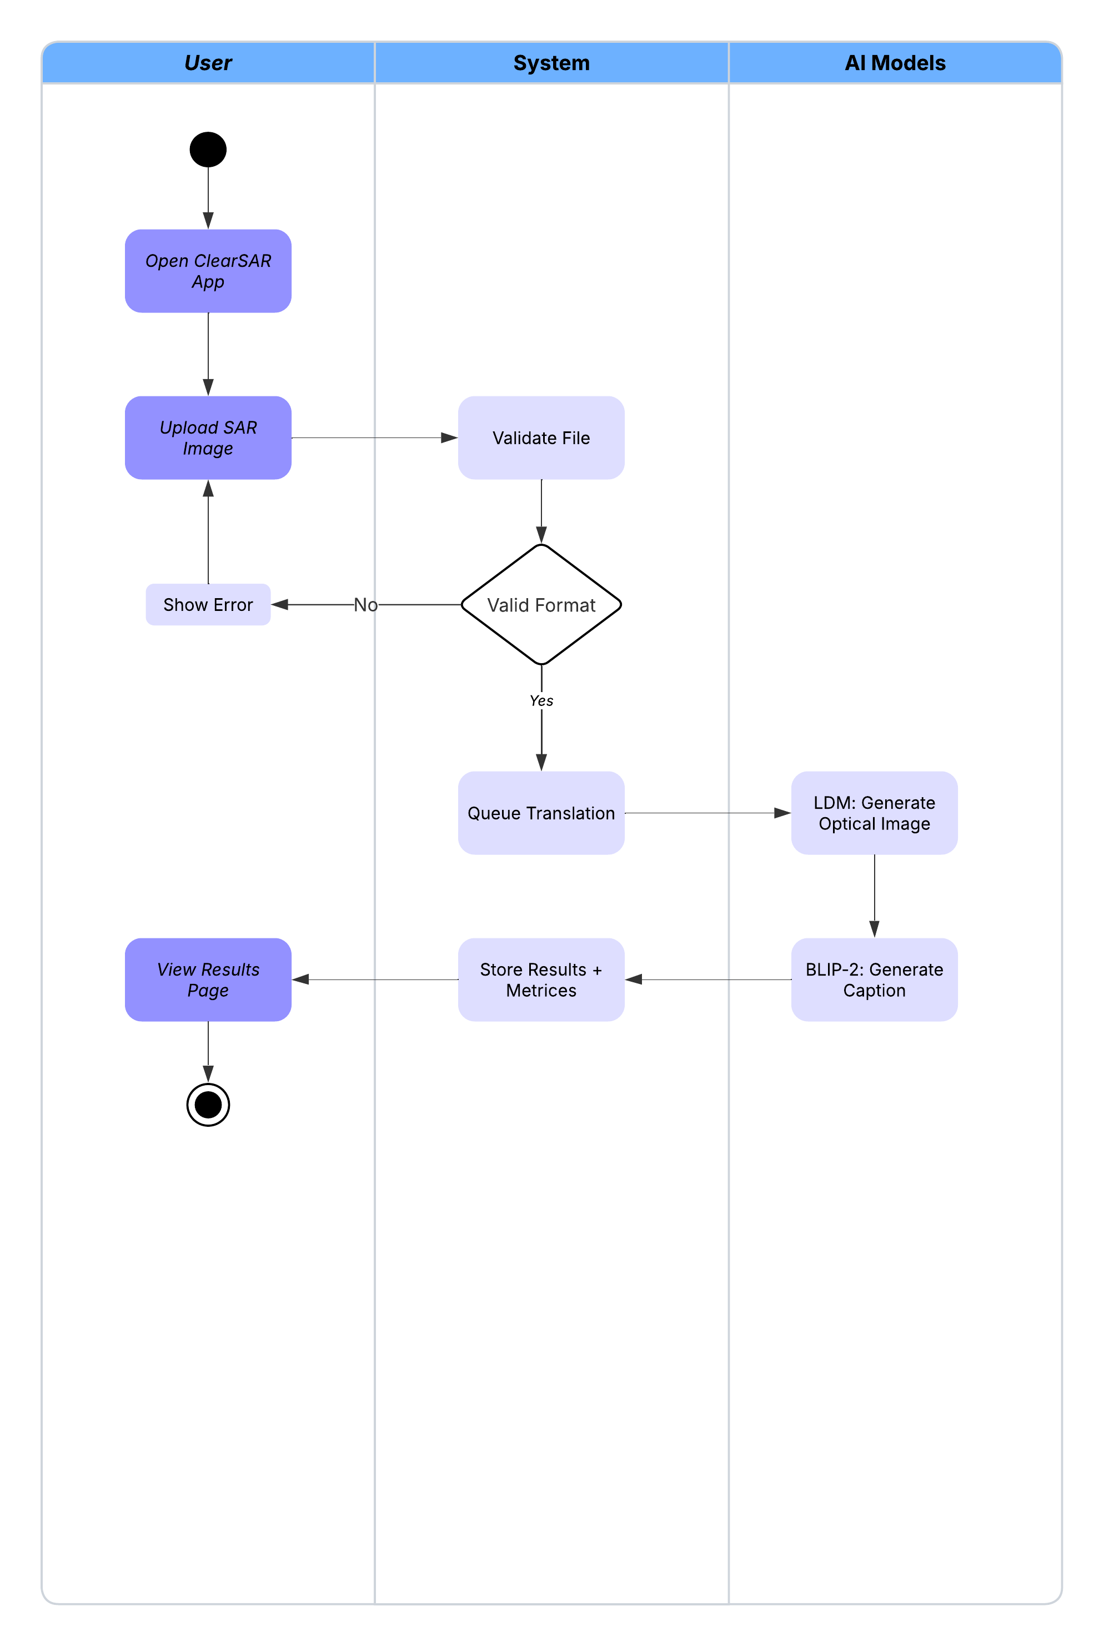
Figure 2 Acitivity Diagram for ClearSAR

4.5 Package Diagram
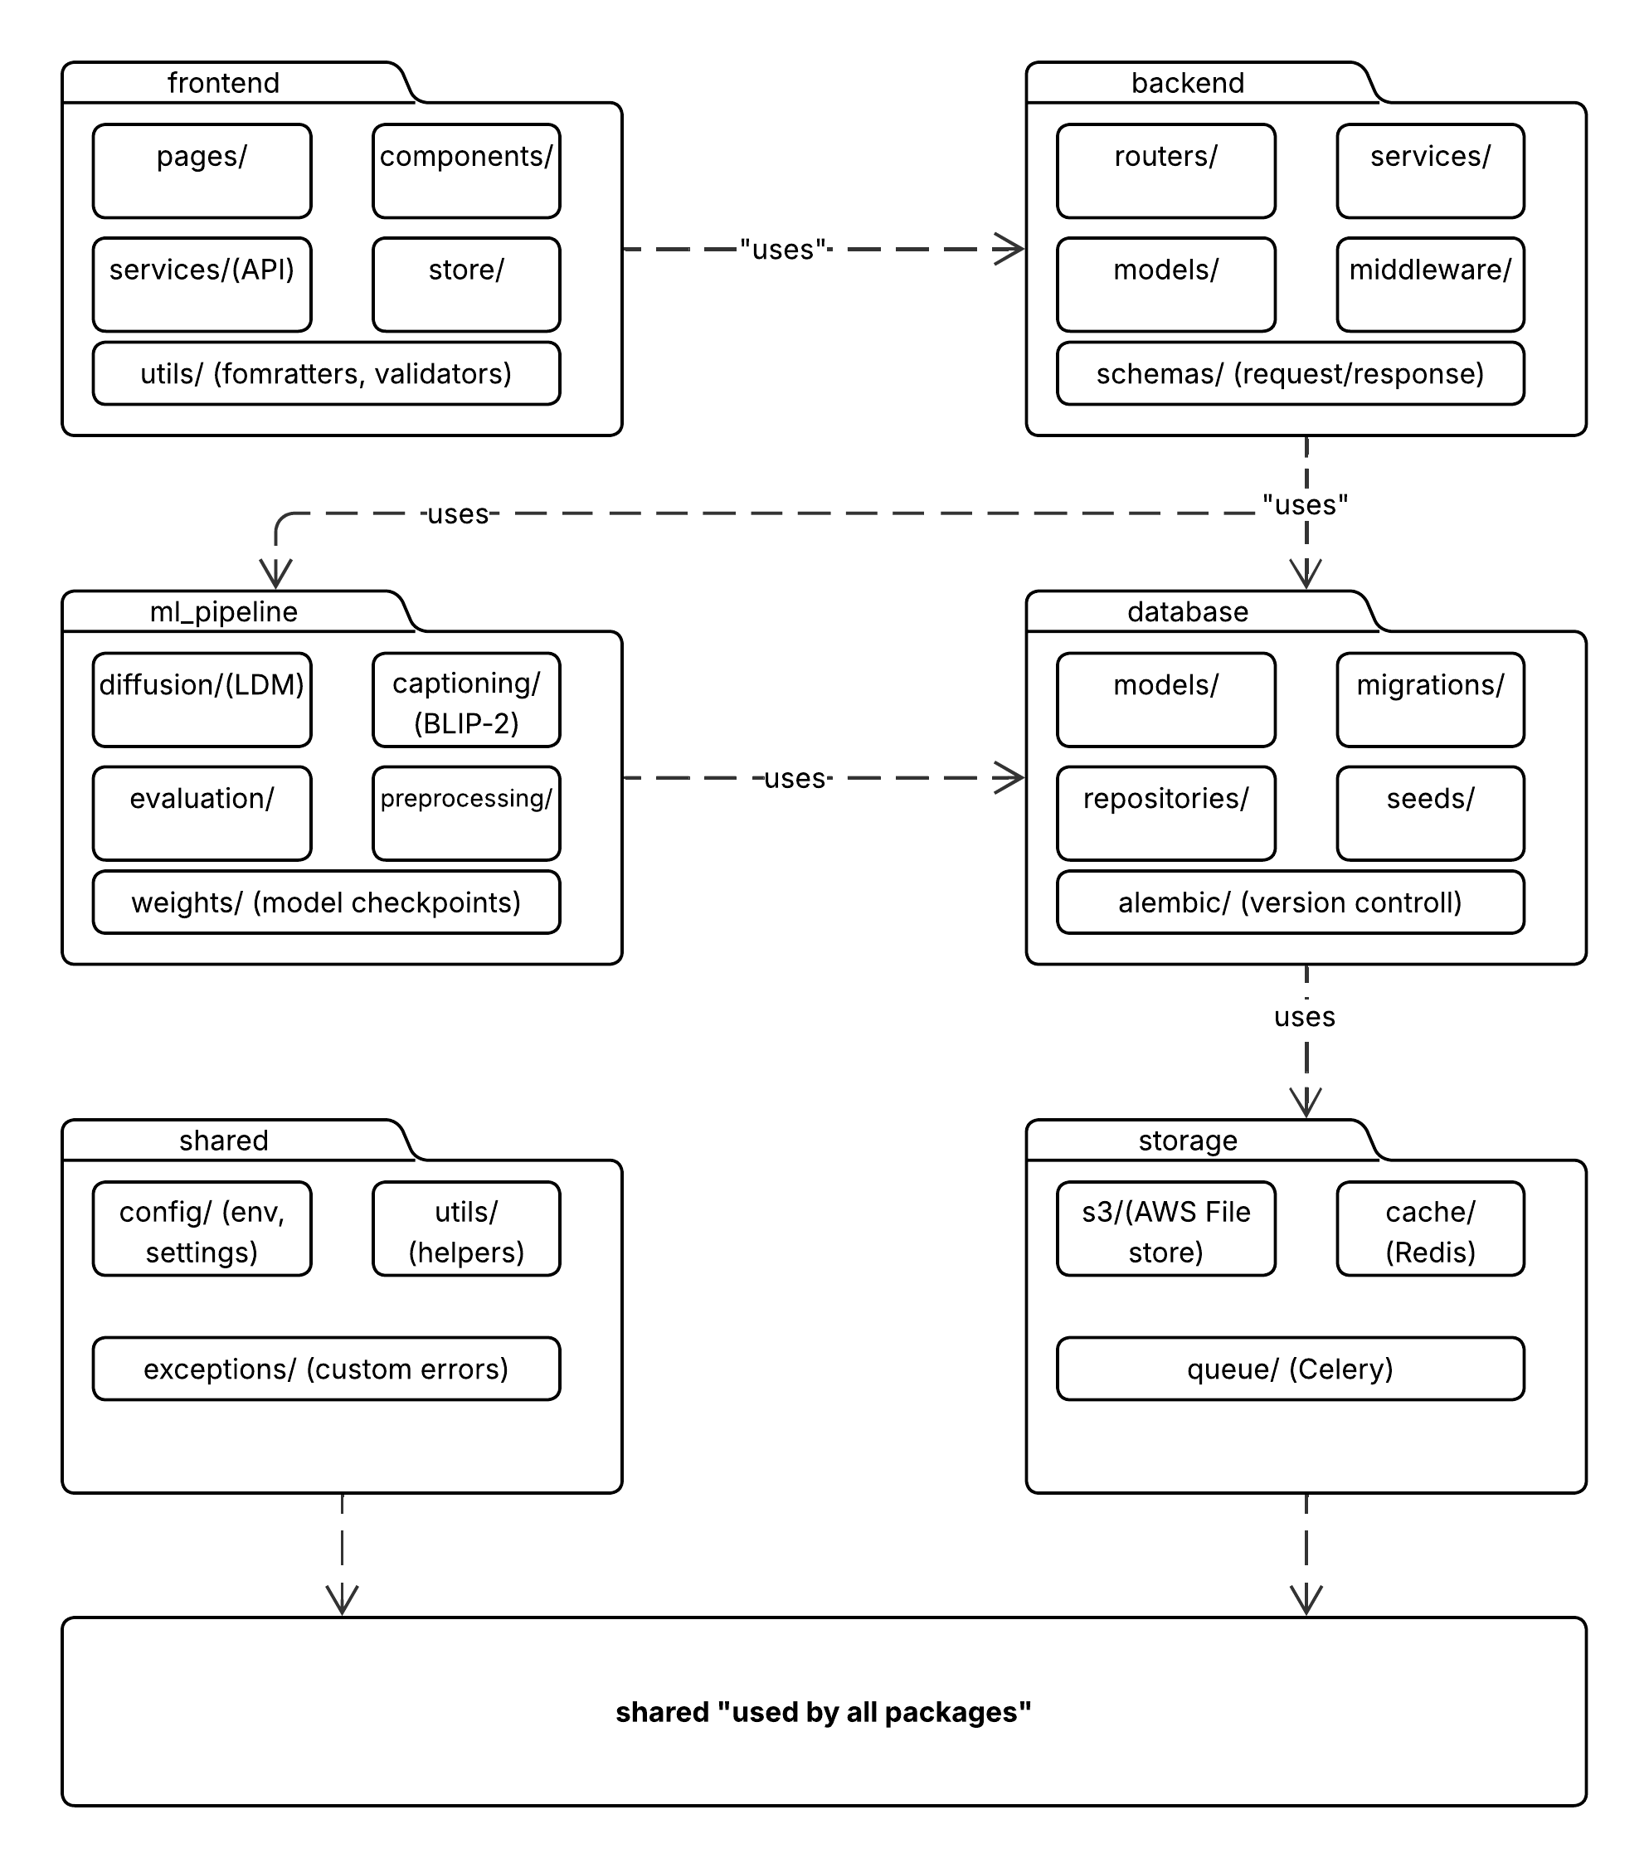
Figure 3 Package Diagram For ClearSAR

4.6 Sequence Diagram
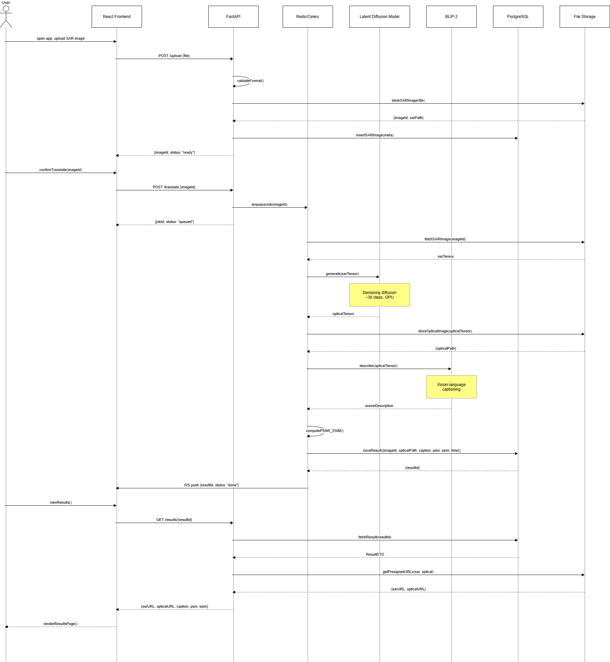
Figure 4 Sequence Diagram for ClearSAR

4.7 System Sequence Diagrams

4.7.1 Upload SAR Image
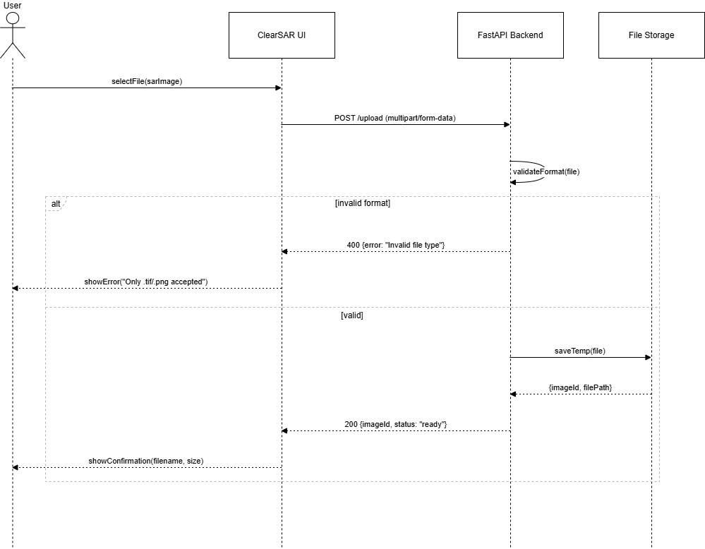

Figure 5 SSD Upload SAR Image

4.7.2 Translate Image
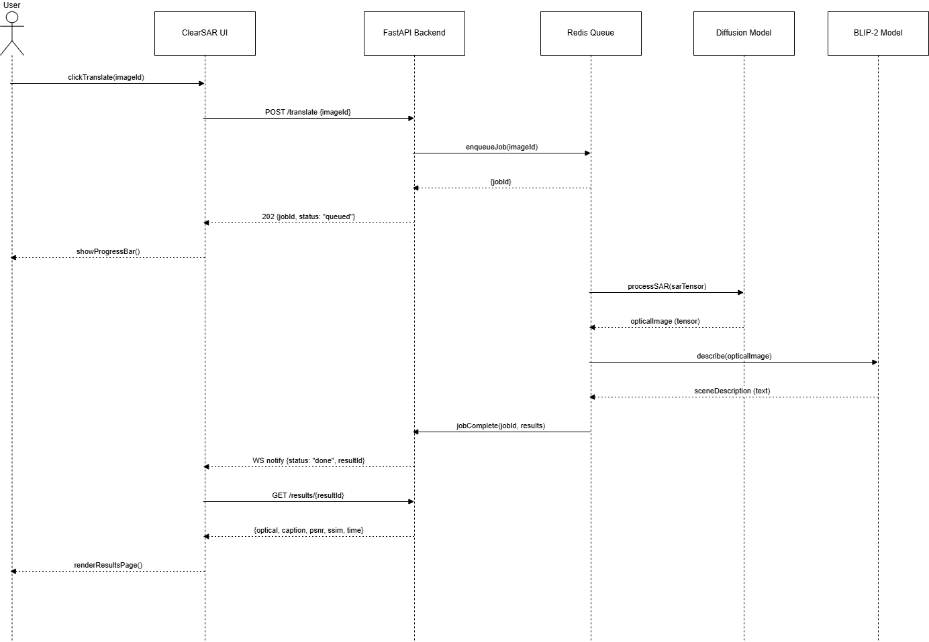
Figure 6 SSD Translate Image

4.7.3 View Results
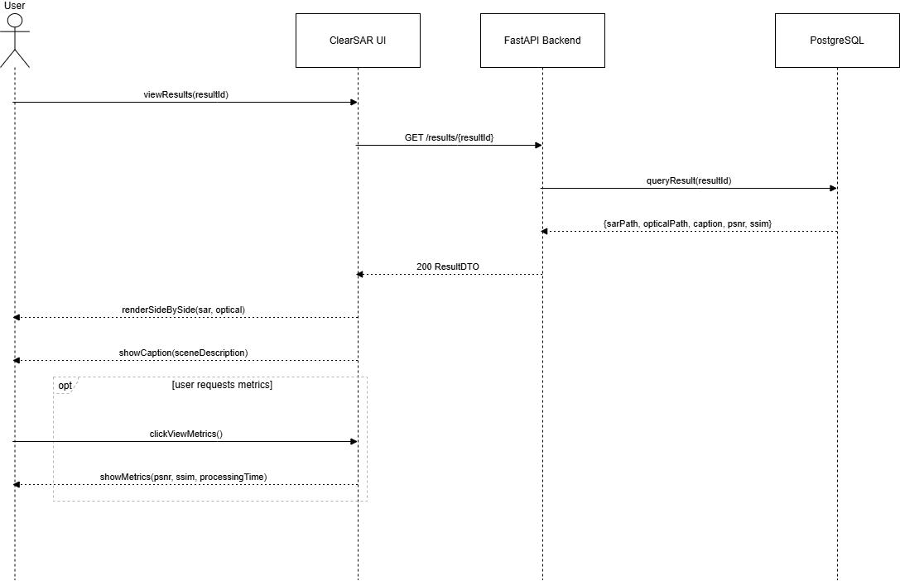
Figure 7 SSD View Results

4.7.4 Monitor Performance
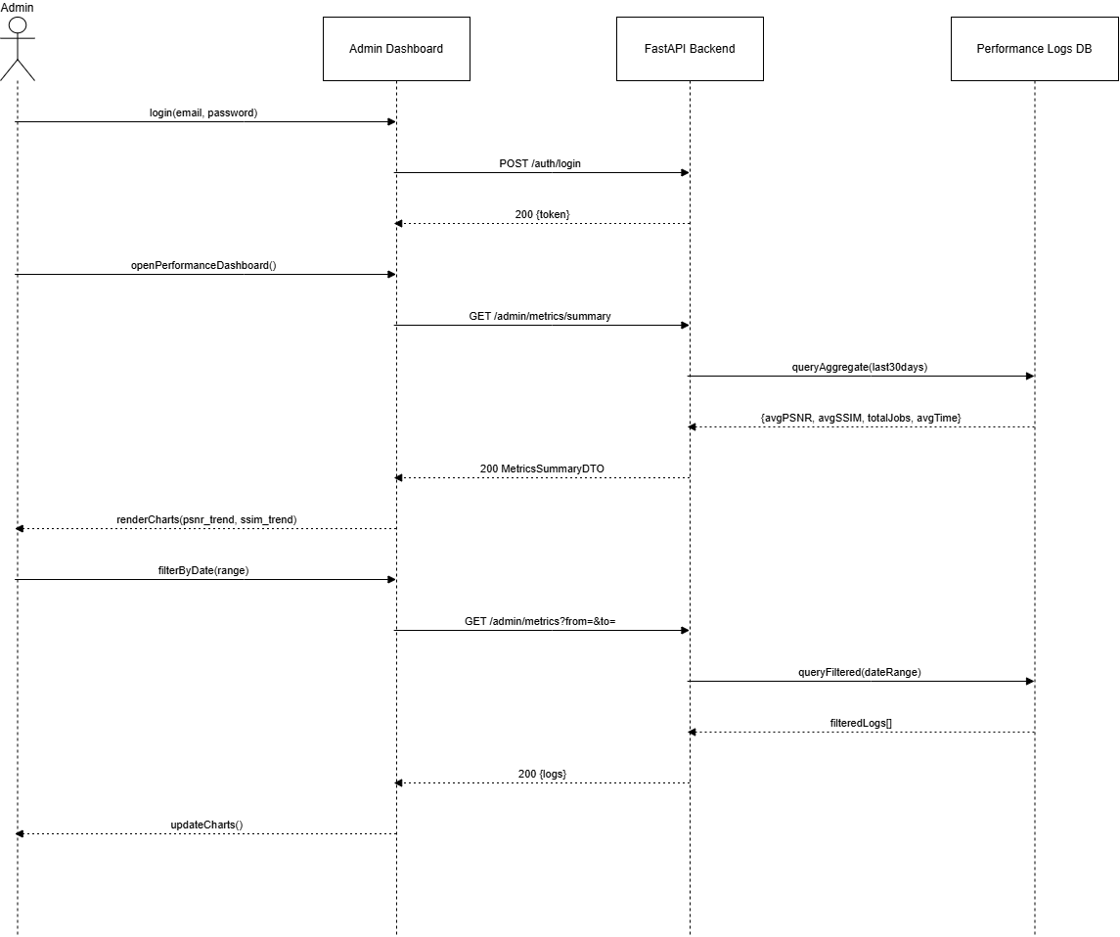
Figure 8 SSD Monitor Performance

4.7.5 Evaluate Model
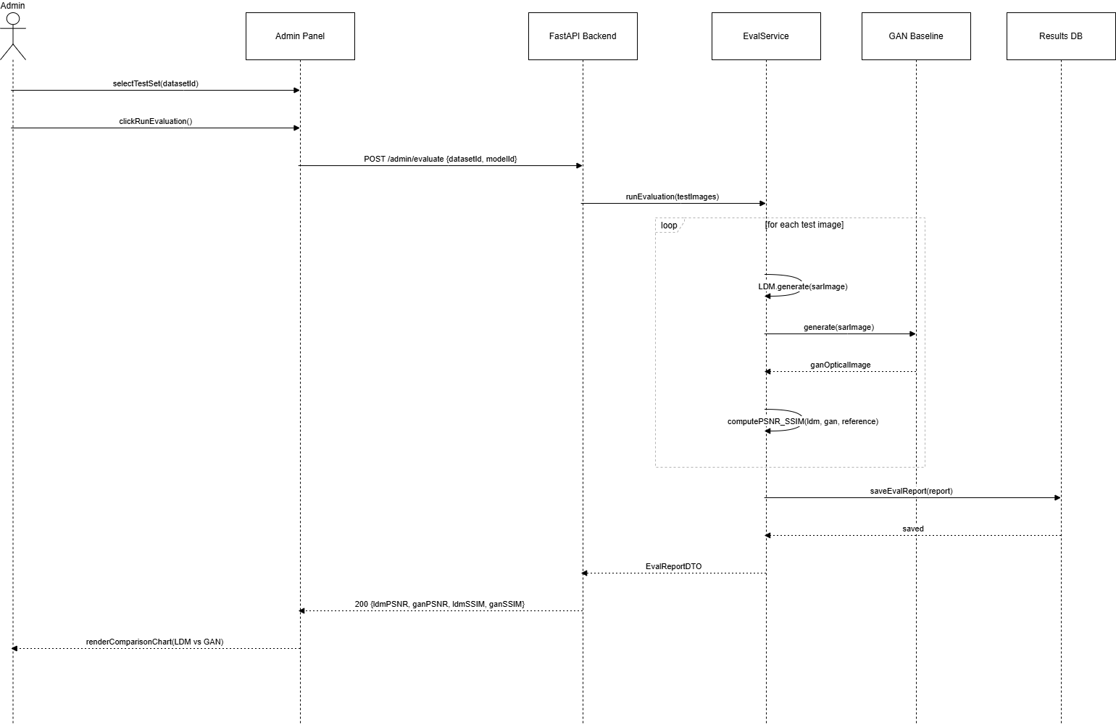
Figure 9 SSD Evaluate Model

4.7.6 Manage Dataset
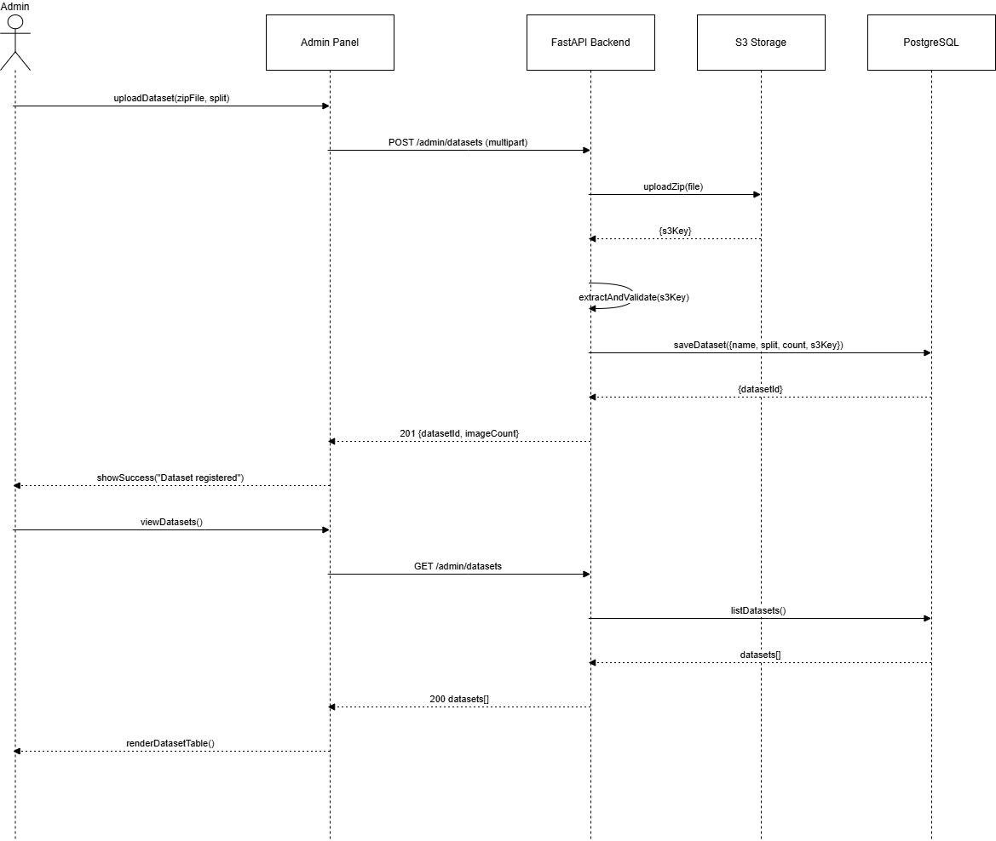
Figure 10 SSD Manage Dataset

4.8 Data Flow Diagram
The Following section graphically illustrates the data flow for ClearSAR.

4.8.1 Data Flow Diagram: Level 0
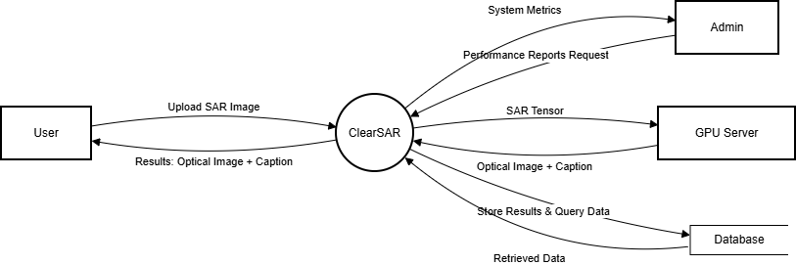
Figure 11 DFD Level 0 for ClearSAR

4.8.2 Data Flow Diagram: Level 1
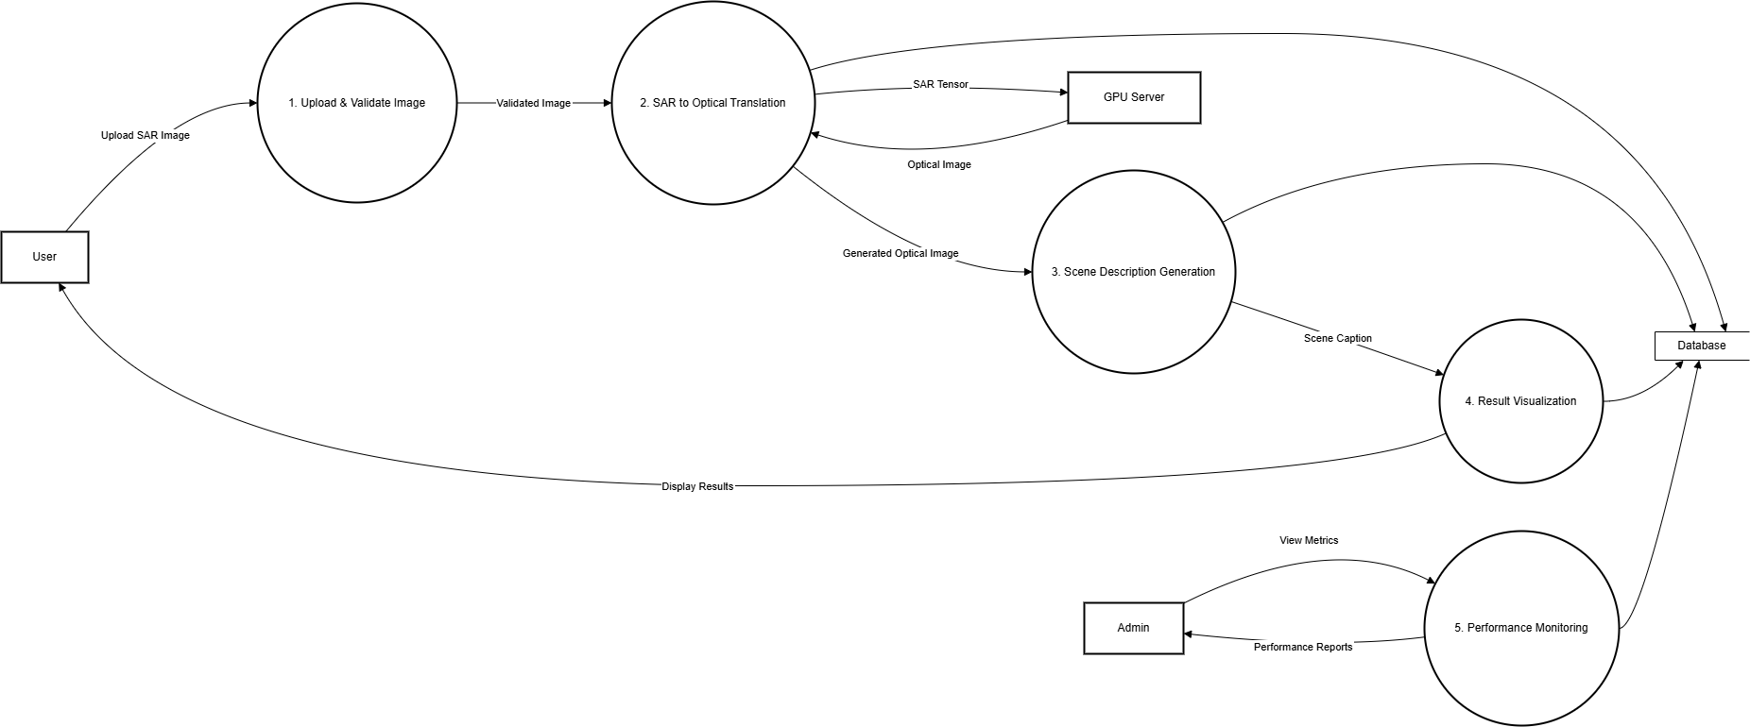
Figure 12 DFD Level 1 for ClearSAR

4.8.3 Data Flow Diagram: Level 2: Translation Process

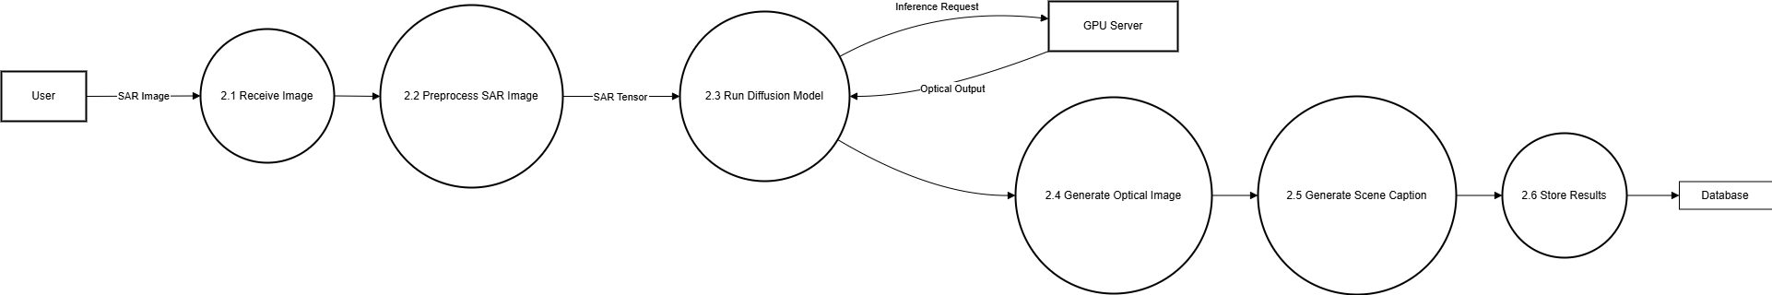
Figure 13 DFD Level 2: Translation Process for ClearSAR

4.9 Deployment Diagram

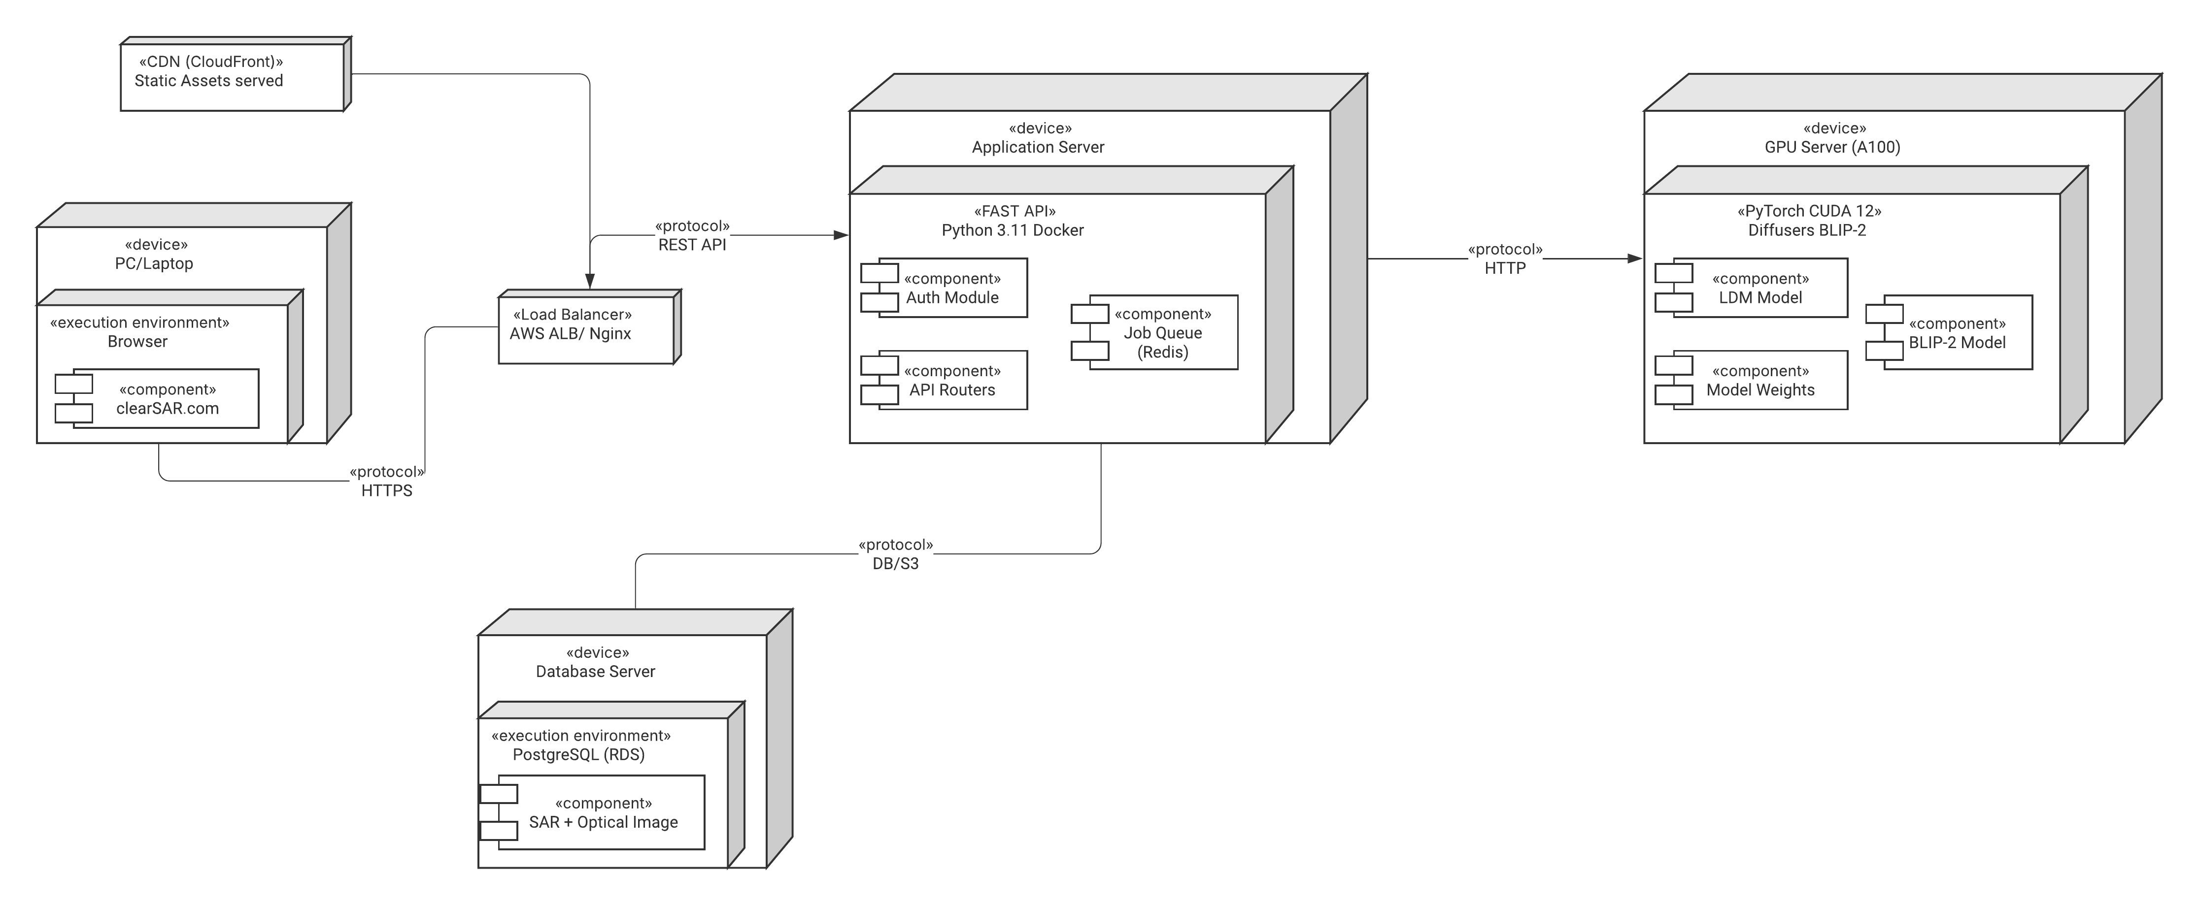
Figure 14 Deployment Diagram for ClearSAR

4.9 Component Diagram

5. References
Bai, X., Pu, X. and Xu, F. (2023) ‘Conditional diffusion for SAR to optical image translation’, IEEE Geoscience and Remote Sensing Letters.

Bass, L., Clements, P. and Kazman, R. (2021) Software architecture in practice. 4th edn. Boston: Addison-Wesley.

Booch, G., Rumbaugh, J. and Jacobson, I. (2005) The unified modeling language user guide. 2nd edn. Boston: Addison-Wesley.

Hore, A. and Ziou, D. (2010) ‘Image quality metrics: PSNR vs. SSIM’, Proceedings of the 20th International Conference on Pattern Recognition (ICPR), pp. 2366–2369.

Hughes, L.H., Schmitt, M., Mou, L., Wang, Y. and Zhu, X.X. (2018) ‘Identifying corresponding patches in SAR and optical images with a pseudo-siamese CNN’, IEEE Geoscience and Remote Sensing Letters, 15(6), pp. 784–788.

Isola, P., Zhu, J.Y., Zhou, T. and Efros, A.A. (2017) ‘Image-to-image translation with conditional adversarial networks’, Proceedings of the IEEE Conference on Computer Vision and Pattern Recognition (CVPR), pp. 1125–1134.

Kwak, G.H. and Park, N.W. (2024) ‘Assessing the potential of multi-temporal conditional generative adversarial networks in SAR-to-optical image translation for early-stage crop monitoring’, Remote Sensing, 16(7), p. 1199.

Li, J., Li, D., Savarese, S. and Hoi, S.C.H. (2023) ‘BLIP-2: Bootstrapping language-image pre-training with frozen image encoders and large language models’, Proceedings of the International Conference on Machine Learning (ICML).

Meta Platforms Inc. (2023) React — A JavaScript library for building user interfaces. Available at: https://react.dev
(Accessed: 14 March 2026).

Pan, Y., Khan, I.A. and Meng, H. (2023) ‘SAR-to-optical image translation using multi-stream deep ResCNN of information reconstruction’, Expert Systems with Applications, 224, p. 120040.

Ramírez, S. (2023) FastAPI — Modern, fast (high-performance) web framework for building APIs with Python. Available at: https://fastapi.tiangolo.com
(Accessed: 14 March 2026).

Reitz, K. and Schlusser, T. (2016) The Hitchhiker's Guide to Python. Sebastopol: O’Reilly Media.

Rombach, R., Blattmann, A., Lorenz, D., Esser, P. and Ommer, B. (2022) ‘High-resolution image synthesis with latent diffusion models’, Proceedings of the IEEE/CVF Conference on Computer Vision and Pattern Recognition (CVPR), pp. 10684–10695.

Schmitt, M., Hughes, L.H., Qiu, C. and Zhu, X.X. (2018) ‘SEN12MS — A curated dataset of georeferenced multi-spectral Sentinel-1/2 imagery for deep learning and data fusion’, ISPRS Annals of the Photogrammetry, Remote Sensing and Spatial Information Sciences, IV-2, pp. 153–160.

Shi, H., Cui, Z., Chen, L., He, J. and Yang, J. (2024) ‘A brain-inspired approach for SAR-to-optical image translation based on diffusion models’, Frontiers in Neuroscience, 18, p. 1352841.

Sommerville, I. (2016) Software engineering. 10th edn. Harlow: Pearson.

Wang, Z., Bovik, A.C., Sheikh, H.R. and Simoncelli, E.P. (2004) ‘Image quality assessment: From error visibility to structural similarity’, IEEE Transactions on Image Processing, 13(4), pp. 600–612.

Xiong, Q., Li, G., Yao, X. and Zhang, X. (2023) ‘SAR-to-optical image translation and cloud removal based on conditional generative adversarial networks: Literature survey, taxonomy, evaluation indicators, limits and future directions’, Remote Sensing, 15, p. 1137.

Zhang, M., Zhang, P., Zhang, Y., Yang, M., Li, X., Dong, X. and Yang, L. (2024) ‘SAR-to-optical image translation via an interpretable network’, Remote Sensing, 16(2), p. 242.

Zhao, Y., Celik, T., Liu, N. and Li, H.C. (2022) ‘A comparative analysis of GAN-based methods for SAR-to-optical image translation’, IEEE Geoscience and Remote Sensing Letters, 19, pp. 1–5.

Zhu, J.Y., Park, T., Isola, P. and Efros, A.A. (2017) ‘Unpaired image-to-image translation using cycle-consistent adversarial networks’, Proceedings of the IEEE International Conference on Computer Vision (ICCV), pp. 2223–2232.

